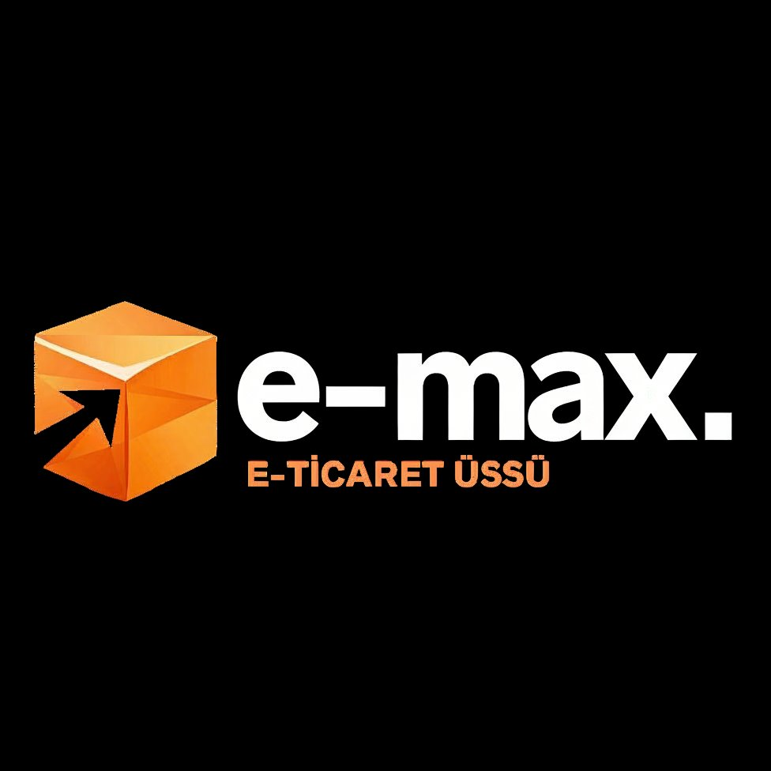
E-COMMERCE FULFILLMENT HUB
ESKİŞEHİR · TÜRKİYE
Leave the operation to us.
You focus on growth.
ABOUT THE COMPANY · COMPANY BRIEF
Prepared for WORLDEF — Cross-Border E-Commerce Summit

75,000 m²  SCALABLE WAREHOUSE CAPACITY | 0.01%  OPERATIONAL ERROR | 1 BUS. DAY  DELIVERY (TR) | 5 DAYS  ONBOARDING
AT A GLANCE
E-MAX is an integrated e-commerce fulfillment hub based in Eskişehir, Türkiye. We take full ownership of operations — warehousing, pick & pack, shipping, returns, and reporting — so growing brands can focus on what actually grows them: product, marketing, and customers.
Backed by Cankap Group and operating from a scalable 75,000 m² facility, E-MAX serves multiple D2C brands simultaneously with a measured operational error rate of 0.01% and 1-business-day delivery to most of Türkiye. Our long-term vision is to become the most automated, AI-driven fulfillment hub connecting Türkiye to global e-commerce.
This brief introduces our company, our vision, our robotics roadmap, and the partnerships we are building at WORLDEF.

Who We Are
COMPANY OVERVIEW
E-MAX (e-max.co) is a next-generation fulfillment operator purpose-built for direct-to-consumer e-commerce brands. Operating from a scalable 75,000 m² facility in Eskişehir — the geographic center of Türkiye — we serve as the operational backbone for multiple D2C brands simultaneously, processing thousands of orders per day with a measured operational error rate of just 0.01%.
We are part of Cankap Group, an established Turkish holding with deep roots in industrial operations. That parent backing gives us something rare in the 3PL space: institutional reliability combined with start-up speed. One contract, one operator, one accountable team — that is the entire E-MAX promise.

What we do, in one line
We absorb the operational chaos of e-commerce so brands can scale without hiring a logistics team.

The services under one roof
- Warehousing — Tiered storage across bin, shelf, and pallet locations. You only pay for the space you actually consume.
- Pick & Pack — SKU-level accuracy with brand-specific packaging. Every box reflects your brand, not ours.
- Shipping — Multi-carrier integration with same-day dispatch and 1-business-day delivery to most of Türkiye.
- Returns Management — Inspection, restocking, and refurbishment closing the loop — turning returns from cost into recovered inventory.
- Reporting — Real-time dashboards, monthly space and order reports, and full visibility through our WMS.

Our Vision
OUR VISION
To become the most automated, AI-driven fulfillment hub connecting Türkiye to global e-commerce — where every order is picked, packed and dispatched faster than any brand could do alone.

E-MAX was not built to be just another warehouse. We are building the operational layer of cross-border e-commerce — a hub where Turkish manufacturing, European demand, and emerging-market growth meet a single, automated logistics backbone.
Today, that means a transparent, flexible 3PL serving the fastest-growing D2C brands in Türkiye. Tomorrow, it means a fully automated, AI-orchestrated fulfillment center capable of fulfilling a Berlin order, a Riyadh order, and an Almaty order from the same shelf — within the same business day.

Our Mission
- For brands — Make operations invisible. Let founders ship faster than their competitors without ever touching a forklift.
- For the ecosystem — Establish Türkiye — and specifically Eskişehir — as a serious, technology-forward fulfillment node for global e-commerce.
- For our team — Build the most advanced, automated, and humane warehouse operation in the region. Where robots handle the repetition and people handle the judgment.

Why E-MAX
Four principles separate E-MAX from a traditional warehouse rental:
TRANSPARENCY  No surprises on the invoice. Every bin, shelf, and pallet is a separate line item. You only pay for what you use. | FLEXIBILITY  Volume-based pricing. As your order volume grows, your unit cost goes down. You win as you scale.
SCALE  75,000 m² of operational infrastructure backed by Cankap Group. The same system handles 10× your current volume. | UNIFIED OPERATION  Storage, pick & pack, shipping, returns and reporting — one operator, one contract, one accountable team.

Why Eskişehir, not Istanbul
Most Turkish 3PLs are clustered around Istanbul — and they pay for it. We made a deliberate strategic decision to build outside that gravity well:
- Up to 40% cost advantage — rent, labor, and overhead are materially lower than the Istanbul belt — savings that flow directly to our clients.
- 1-business-day delivery — to most of Türkiye, certified. Eskişehir's central position is a logistics asset, not a compromise.
- Stable workforce — low staff turnover, well-trained teams, long tenure — operations stay consistent month after month.
- Geographic center — balanced reach to east-west and north-south Türkiye. The same shelf can serve Izmir, Ankara, and Trabzon at parity.

Robotics & Automation Roadmap
THE NEXT FIVE YEARS
E-MAX's long-term thesis is simple: the warehouses of 2030 will not look like the warehouses of 2020. The brands winning cross-border e-commerce will be those whose fulfillment partners invested early in automation, AI, and robotics. We are building toward that future on a clear, phased roadmap:

HORIZON | FOCUS | TECHNOLOGY | OUTCOME | STATUS
2025 | Smart WMS & data layer | Real-time WMS, IoT scanning, BI dashboards | Sub-1% error, full traceability | LIVE
2026 | Assisted picking | Pick-to-light, voice picking, AI slotting | 2× picker productivity | In rollout
2027 | Goods-to-person robotics | AMR fleet, conveyor sortation, ASRS modules | 24/7 lights-out zones | Pilot planned
2028+ | Autonomous fulfillment | Robotic arms, computer vision QC, AI demand routing | Truly automated cross-border hub | Roadmap

By 2028, our goal is to operate one of the most automated fulfillment hubs in the EMEA region — combining AMR fleets (autonomous mobile robots), Goods-to-Person picking stations, robotic arms for variable SKUs, and computer-vision quality control, all orchestrated by an AI layer that learns from every order.

The Future of Warehousing
INDUSTRY OUTLOOK
Global warehousing is undergoing the deepest structural shift in 50 years. Five forces are reshaping how the world stores and ships:
- Robotics goes mainstream — AMRs and Goods-to-Person systems are moving from Amazon-only to mid-market 3PLs. By 2030, automated picking is expected to cover the majority of e-commerce SKUs globally.
- AI becomes the warehouse manager — Machine-learning models will handle slotting, demand forecasting, labor planning, and route optimization in real time — replacing the spreadsheets that still run most warehouses today.
- Micro-fulfillment & regional hubs — Same-day delivery expectations are pushing fulfillment closer to consumers. Networks of mid-sized regional hubs — exactly the Eskişehir model — replace mega-warehouses on city outskirts.
- Cross-border becomes frictionless — Customs digitization, unified marketplace integrations, and bonded fulfillment will let a single warehouse serve dozens of countries without re-storing inventory.
- Sustainability moves from PR to P&L — Energy-efficient robotics, right-sized packaging, and consolidated shipping become competitive advantages — not compliance checkboxes.
E-MAX's strategy is to ride all five waves at once. Eskişehir gives us the cost base, Cankap Group gives us the capital, our WMS gives us the data layer, and our roadmap gives us the timing. The next decade of warehousing will be won by operators who automate early and partner deeply — and that is exactly what we are building.

E-MAX at WORLDEF
WHY WE ARE AT WORLDEF
WORLDEF is the meeting point of cross-border e-commerce. We are here to do four things:
- Meet ambitious brands scaling into Türkiye and the EMEA region who need a reliable fulfillment partner.
- Build cross-border partnerships with marketplaces, 3PL networks and last-mile carriers across Europe, MENA and Central Asia.
- Showcase the E-MAX model — Eskişehir as a strategic, lower-cost alternative to Istanbul-based fulfillment.
- Engage robotics & automation providers to accelerate our 2026–2028 automation roadmap.

Who we want to meet
- D2C brands — scaling to or within Türkiye, EMEA, and Central Asia — particularly fashion, beauty, supplements, home, and accessories.
- Marketplaces & platforms — Trendyol, Hepsiburada, Amazon, Etsy, Shopify ecosystems looking for reliable Turkish fulfillment partners.
- Cross-border carriers — and last-mile providers expanding their EMEA networks.
- Automation & robotics vendors — AMR, ASRS, pick-to-light, computer vision, WMS and AI orchestration providers.
- Investors & strategic partners — interested in the future of Turkish logistics and cross-border e-commerce infrastructure.

“
E-MAX is not a warehouse.
It is your brand's operational infrastructure.
— E-MAX
LET'S TALK FULFILLMENT
Visit us at WORLDEF or reach out anytime.
Email info@e-max.co
Phone +90 538 866 24 99
HQ 75. Yıl OSB, 35. Cadde No: 11, 26250 Odunpazarı / Eskişehir · Türkiye

